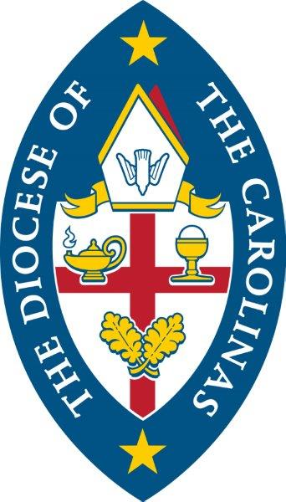
St. Mary Magdalene Anglican Church
914 Market St. Camden, SC 29020

Christian Giving for 2024

10 January 2024

Dearest Saints of St. Mary Magdalene Anglican Church,

As we start the New Year and the season of Epiphany, it is fitting that we look to the future by examining the past. That is the purpose of Epiphany. We look back to the manifestation of Christ to the Gentiles. We are called to evaluate our response and to rededicate ourselves to the mission of The Church to present Christ as the revealed devine nature of God--The Way, The Truth and The Life for all of humanity. It is the mission of The Church to proclaim Jesus as the incarnation of God, fully human yet fully God. As you consider how you will help, there are three areas that are essential to the mission: Time, talent and treasure. Please consider how all three are critical to the church, the body of Christ. Time and talent to grow your faith and provide the church with the talent and gifts God has given you to be used for such a time as this. Treasure to support the church with the monetary resources needed to maintain a presence in the community as a beacon of hope and a place of healing to help change our community. This church has always done that and I am thankful and blessed by your faithfulness. As you prayerfully consider these things, I trust you will return to God a portion of what He has given you to support His church. Please fill out the enclosed Form for Christian Giving and place it in the collection at the Offertory on January 21 or, at the latest, January 28. Your 2024 pledge should begin in February.

God Bless you all,

Fr. bill+

